Custom Controls Internal Training #5
Vykon Pro – Global Commands and BQL Queries
Overview
The Vykon Pro Modules are a set of modules released through the Vykon Niagara sales channel. Vykon is the brand name applied to a JACE if it is sold direct from Niagara as opposed to a controls manufacture like Honeywell or Distech. The modules offer some additional functionality to really step up the functionality of a station if implemented correctly. The modules are not vendor locked, so they can be used on any brand of JACE, but they are version specific.
Installing Vykon Pro
To install Vykon Pro, download the zip file for the appropriate version from jacksonfiles.com. Open the zip folder and drag the content into the directory C:\Niagara\EC-Net4-4.x.x.x\modules. If workbench is open, it will have to be closed and restarted before the new modules will be recognized.
To install Vykon Pro on a JACE, open a platform connection, and select software manager. Scroll down and highlight all of the Vykon Pro Modules. Click the install button, and then click commit.
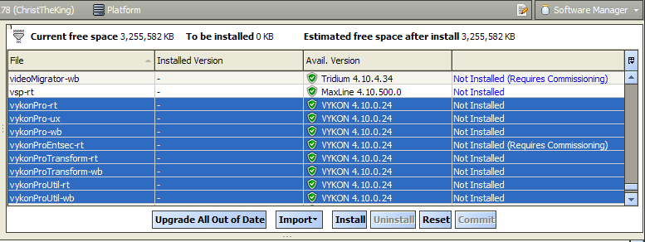
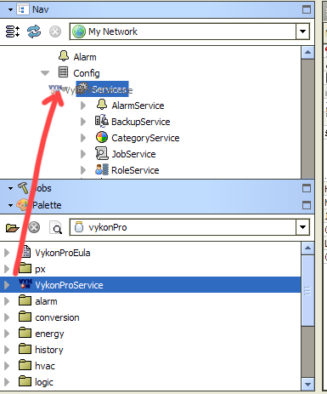

The final step for installing Vykon Pro on a JACE is to install the VykonProService. In workbench, open the palette window on the left-hand side is not already open, from the menu bar at the top select “Window”, then “Sidebar”, then select “Palette”. Next, click the open folder icon in the palette window. A popup will appear. Type “vykonPro” in the filter field. The history module is now listed and highlighted. Click “OK” button. The VykonPro palette is now visible. Drag the VykonProService to the services container for the station.

Global Commands
Almost no company installing Niagara products knows how to properly implement global commands using VykonPro. Understanding how to properly implement a global setpoint command or global override is a key skill to making a station simpler to use and potentially streamline the balancing process.
Example 1 – What Not Do
Before learning to implement a global setpoint command properly, it is important to learn what not to do. Most global commands implemented by other contractors will use the incorrect method seen below. A tech that understands both the poor implementation and the correct implementation can correct a poor implementation efficiently, provide value by improving the usability of the station, and explain the improvement to the customer such that the customer feels Jackosn Systems is bringing a superior level of expertise to their control system.
Poorly Implemented Global Setpoint Command
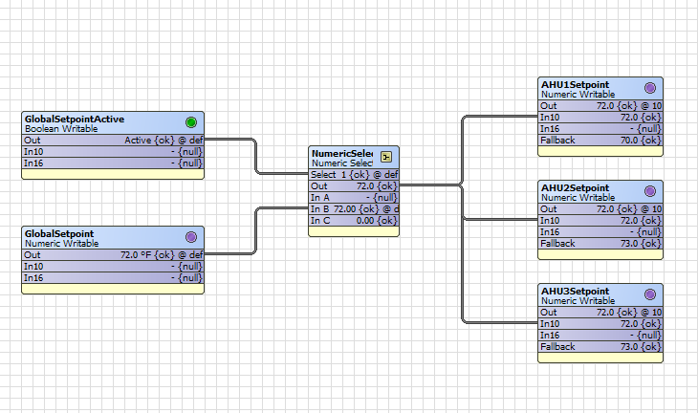

In this implementation, the user must interact with the GlobalSetpointActive point. This value forces the NumericSelect block in the middle to choose between a null value when the GlobalSetpointActive is false and the GlobalSetpoint when the GlobalSetpointActive is true. When the GlobalSetpointActive point is true, the AHUs then have their setpoint’s fallback value superseded by the value being written at a higher priority level (10 in this case).
This approach has a couple of drawbacks. First, requiring the user to interact with and understand the GlboalSetpointActive command is one more point of potential human error. Second, this is an all or nothing approach; individual setpoints cannot be set from their respective equipment PX pages because the set function will only write to the fallback which is at a lower priority than the global command. Third, it removes the occupant’s ability to adjust the setpoint from the space sensor if that functionality is present and otherwise desired.
Example 2 – Global Setpoint
For this example, the target will be the occupied setpoint of VAV controllers. The GlobalCommand objects are found in the vykonProUtil pallet. Open this palette in the manor previously instructed for the vykonPro pallet. Create a folder under the drivers container called “GlobalSetpoints” and drag a GlobalNumericWritableCommand block from the palette into the newly created folder. Rename the newly created block something like “OccupiedSetpointGlobalCommand”. Double click on the block to be presented with the property sheet that will allow the global command to be configured. The configuration options are described below:
- Start Ord – If the global command is targeting every setpoint of the same name in a facility, the Start Ord can be “station:|slot:/Drivers”. If the intention is to target specific floors or areas of a facility, the controllers would need to be divided into device folders which can be targeted as the Start Ord. In the case of Lon systems, specific Lon networks can also be targeted if they are already divided in a useful way.

- Point Name – The name of the point to be set or overridden. For this example, set the value to “OccupiedSetpoint”.

- FindExactName – Setting this field to “false” would allow for some variation in the name. In general, this should be set to “true”.

- FindExactName – Setting this field to “true” would present the user with a popup confirm which points were set successfully. This might be helpful for troubleshooting, but should generally be set to “false”

- Facets – Set the facets to the correct units so that the units appear correctly in the set popup window.
Global Command Configuration
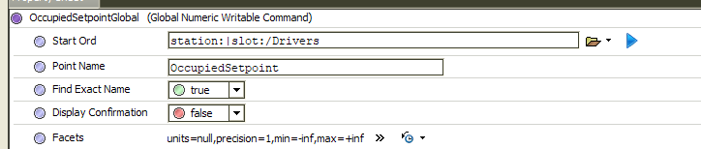
At this point, the global command is configured and should function, but there is one more step to make to enhance the functionality. Right click on the global command block in the nav tree on the left. Next, hover over “new”. Then click “NumericWritable”. Name the new NumericWritable the same as the point being targeted with the global command. Set the facets of the newly created point to appropriate values. For this example, use degrees Fahrenheit. This numeric writable will be used to display the most recently set value by the global command as it will be updated along with the actual setpoints in the controllers.
The final piece to implementing the global command is to make it accessible via a PX. The command is triggered just like a typical setpoint. Copy any setpoint button from an equipment PX file, and place it on the homepage or wherever is appropriate. The ord of the action binding should target the set function of the global command while the ord of value binding will target the NumericWritable point created to display the most recently set value for the occupancy command.
Image Button for Global Command
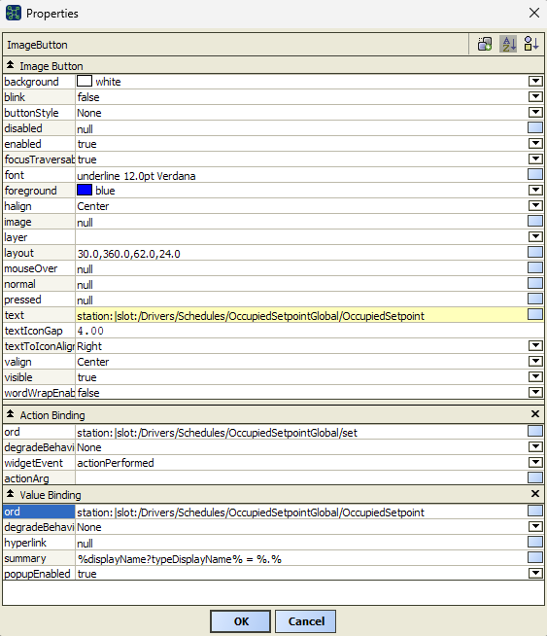

The global setpoint command has now been implemented. The same process can also be used for sending global overrides to equipment for testing and balancing. Simply replace the “set” at the end of the action binding’s ord with the appropriate command such as “active”, “inactive”, “override”, or “auto”.

