Custom Controls Internal Training #4
Networking
IP Address
An address that uniquely identifies a network interface of a computer on a given network. An IP address is made up of 32 bits, for readability, often written in decimal format as 4 sets of 3 digits with 0-255 being possible for each set. Each set can be referred to as an octet as it is made up of 8 bits.
IP addresses can be private or public. Public addresses are accessible directly from the internet. Every modem has one or more public addresses they can assign to devices. Private addresses are reserved exclusively for use inside of a local network. Devices with private addresses cannot communicate directly to the internet. This is required because of the billions of computing devices that need to connect to the internet. While a private address must be unique in each LAN, they are reused across different networks without issue. Without private addresses, each one would need a public address and there would not be enough.
Private Address Spaces
10.0.0.0 to 10.255.255.255 | 172.16.0.0 to 172.31.255.255 | 192.168.0.0 to 192.168.255.255

(Default) Gateway
The gateway is a computer (and associated IP) that forwards network traffic from one network to another. For a small network used in resident or small office, this is often the modem’s IP.
Subnet
A subnet is a set of IPs that can communicate without having to forward traffic to a router. The subnet is denoted with a subnet mask. The subnet mask is 32 bits that determines which IP addresses are in the same network as the device and which IPs are in a different network. This can be written in the decimal format such as 255.255.255.0 or as two digits with a slash like /24. When converted to binary, 255.255.255.0 contains 24 1s so writing /24 denotes the same subnet mask.
When the bits of the IP are aligned with the bits of a subnet mask, any portion of an IP which lines up with a 1 in the subnet mask is called the network portion and any portion aligned with a 0 is called the host portion. Two IPs that share the same network portion are in the same subnet and can communicate without first sending traffic to a gateway.
Messages intended for devices in a different subnet will be sent to the (default) gateway IP configured on that system instead of the actual destination IP. Broadcast messages, which are sent to every device on a subnet, are not forwarded by the gateway to other subnets. The BACnet discover function uses broadcast messages to find devices and as such it will not find devices in other subnets. A broadcast message can be thought of as the device shouting in every direction “who is there?” The other devices then respond back “I am” with their relevant information.

Example
Which IP Addresses can communicate without the use of a gateway?
IP A: 192.168.199.140
IP B: 192.168.207.140
IP C: 192.168.185.140
Subnet: 255.255.192.0

IPA | 11000000 | 10101000 | 11000111 | 10001100
IPB | 11000000 | 10101000 | 11001111 | 10001100
IPC | 11000000 | 10101000 | 10111001 | 10001100
Sub | 11111111 | 11111111 | 11000000 | 00000000

Remember, the network portion must match for two IPs to be in the same subnet. As such, A and B are in the same subnet.
Because the gateway is used to route traffic to IPs outside the machine’s subnet, the gateway must be within the subnet range. Windows will recognize and throw an error if you attempt to set the gateway address outside the subnet. Try it.
One JACE specific consideration exists when dealing with subnets. Because the JACE has a single gateway it can use to forward traffic outside the subnet, only one of the network ports can reach devices outside it’s subnet. As such, the two ports must be in different subnets as the JACE will be unsure which port to send traffic through if both ports could talk to the gateway based on the IP configuration. For example, if the secondary port is to be set at 192.168.1.12/24 with a gateway of 192.168.1.1, the primary port’s IP must be changed from 192.168.1.140 to another subnet such as 192.168.2.140. Failing to do so could cause network communication issues.
MAC Address
The MAC address is a hard coded address that is associated directly with a network interface. The address is made up of 6 two digit hexadecimal numbers. Each 2 digit number is typically separated with a colon or dashes (Ex. 00-B0-D0-63-C2-26) While techniques exist to spoof MAC addresses, in general they cannot be changed and are unique to every device. Network security systems can block devices without known MAC addresses. While not common, these systems may even disable a physical network port if a device with an unknown address connects to it. When requesting an IP address from a network admin for a JACE, it is good practice to supply the MAC address for the port you intend to connect to their LAN. While not always required, offering this information in advance will suggest to the admin that you know what you are doing and lessens the chance they will cause you unnecessary grief.

All of the above discussed values can be found for a particular interface on your laptop via command prompt by typing “ipconfig /all”. Be aware that multiple interfaces will likely appear in the results.
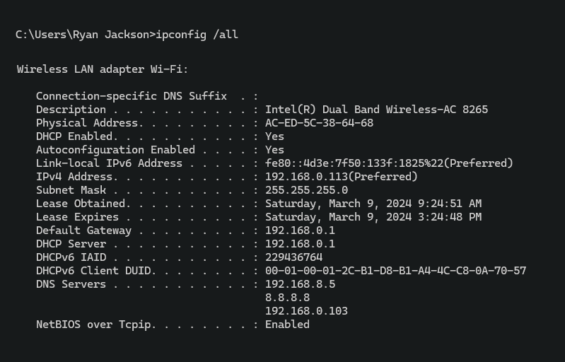

Port
A port is an address on a single machine that can be tied to a specific application. It is not a physical interface or location, but it allows your device to be able to communicate using more than one application. Think of the IP address like a street name and the port number like the building number. Knowing the IP gets you to the machine just like the street name gets you to the street, but unless you know the port number you can’t interact with the right application just like knowing the building number gets you to the right house. Port number is denoted after the IP with a colon.
You need to remember these TCP ports: HTTP: 80, HTTPS 443 (required for ECY controllers), Fox: 1911, GFX: 1931, Platform S: 5011
These port numbers can be changed if required for a specific site. HTTP port can be changed in web service. Fox port can be changed from the Fox Service. GFX can be changed from Wizard Service. Platform can be change from Platform Administration.
NAT
NAT stands for network address translation. It is a way for a router to repackage and send information to a private address space from the public Internet. A NATed device is not directly accessible from the Internet.
DNS
A DNS is a server which converts named addresses to the IP addresses. Some named addresses can have multiple or dynamic IPs, so using the name as opposed to the numeric address assures your computer will get the correct IP to connect to. For Tridium, we most commonly use the DNS to resolve the email server IP for smtp.office365.com. Google has a public DNS at IP 8.8.8.8. The JACE will query 8.8.8.8 for the current IP and will receive a response back which contain the current IP for that name.
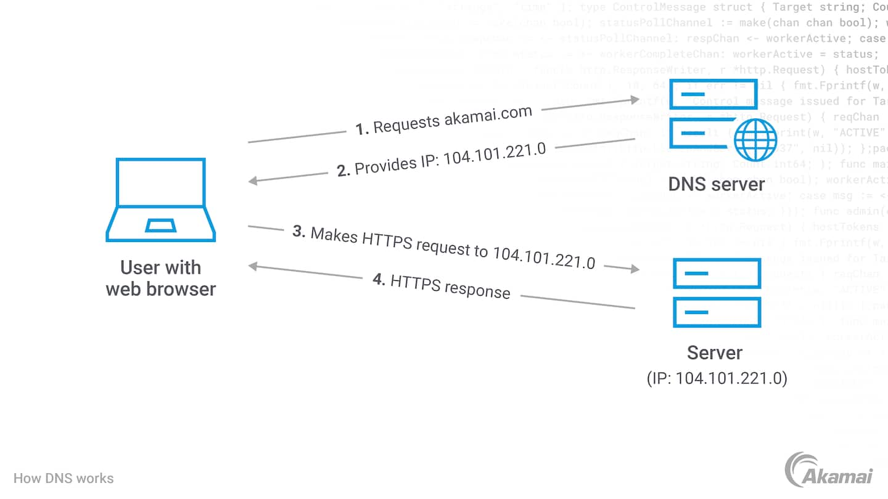
DHCP
DHCP stands for Dynamic Host Configuration Protocol and is a service, typically provided by a router, which assigned the IP address, subnet mask, gateway, and DNS to a device. The assigned IP can change over time unless the router is configured to assign the same address each time to a given MAC address. It is not advisable to use DHCP as a permanent solution for network confirmation for a JACE. This is because if the JACE, unlike a PC, boots without a response to its DHCP request for the networking configuration, it won’t try again until the next boot which renders that interface inaccessible.
Network Switch
A switch is a networking device that connects two or more physical and logical segments of a network based on MAC address alone. Switches store a list of accessible MAC addresses on each port and forward requests to the appropriate port to minimize traffic on the various network segments. This is in contrast. to older devices like hubs which rebroadcast all traffic. Most modems from ISPs will have switches built in for connecting multiple devices. Because a switch works purely off MAC addresses, there is no right or wrong IP address range on a given switch.
Consider this real-world example. A service call comes in after a change in the networking scheme used at a facility. The JACE, with IP of 192.168.1.121, is no longer accessible via the owner’s network which is now using a 10.1.x.x scheme. The JACE is in a locked room and the person with the key is on vacation. The service tech can set their laptop to an IP in the same subnet as the JACE, plug into a port on the switch or even a jack in a room somewhere which is connected to the switch (or another connected switch), and login to the JACE platform to update the IP. Even though every other device in that building is using a 10.1.x.x address and the DHCP server for that building is handing out addresses in that range, the switch doesn’t care.
BBMD
BBMD stands for BACnet Broadcast Management Device. The previously mentioned limitation for BACnet broadcasts and discovery across subnet can be overcome using a BBMD. The BBMD acts as a directed recipient for BACnet broadcasts in another subnet. A BACnet router in another subnet can have the BBMD functionality enabled and then the JACE (or other BACnet/IP device) will direct messages at that BBMD in the remote subnet via the gateway. Once the message reaches the BBMD it will send a broadcast message to all devices on it’s own subnet and repackage the responses and send them back to the JACE via the gateway.
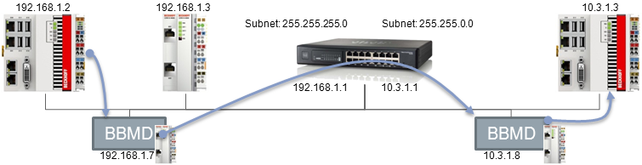
Port Forwarding
Port forwarding is the process of forwarding incoming Internet traffic from a router to a specified host with a private address based on the port number. While it is typical to have the internal and external port numbers match it is not required. In the case of multiple devices using port forwarding on a LAN, using different port numbers may be unavoidable.
Port Forward Table
Public Port | Private Port
63.147.55.57:80 | 192.168.1.140:80
63.147.55.57:81 | 192.168.1.141:80
63.147.55.57:1911 | 192.168.1.140:1911
63.147.55.57:1912 | 192.168.1.140:1911

Configuring Port Forwarding
The default IP for a comcast modem is 10.1.10.1. The IP can be confirmed using ipconfig command in the command prompt and noting the gateway IP. The default credentials for a comcast modem are cusadmin/highspeed. These are usually not changed.
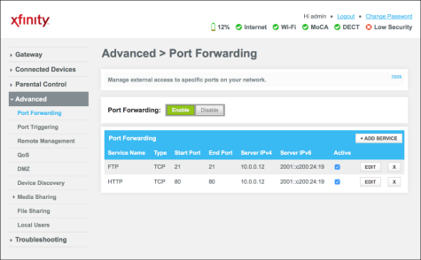

After reaching the port forwarding menu, services for FOX, HTTP, Platform, and Gfx will need to be added using the previously mentioned port numbers.
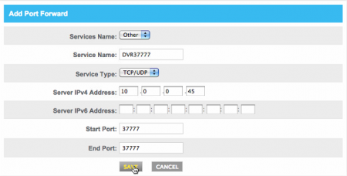
After adding these ports, assign each one to the JACE.
The setup on an ATT modem is similar. The default IP for an ATT modem is 192.168.1.254. Instead of a password, there is a long access code printed on the side that is unique to every modem.
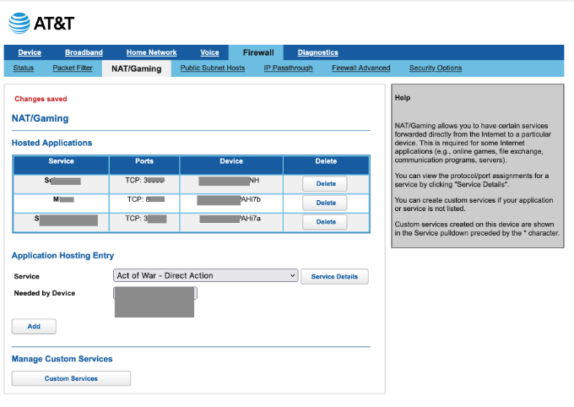
“Custom services” will need to be added for FOX, Platform S, and GFX . An HTTP service is already present in the drop down list so it does not need to be added. After adding these services, assign each one to the JACE.

