Custom Controls Internal Training #3
Trends and Alarms
Overview
Trends and alarms are typically the final pieces added to the control system. As such, they are often overlooked. While not the most critical portion of the system, trends and alarms can assist in trouble shooting and demonstrating to other contractors and owners that the control system is not always the source of their problems.
Creating Trends
While it will not be required to create a trend from the palette for every project (program service is your friend), often there are singular points such as loop pressure that need to have a trend added.
Example 1 – Trend from the History Palette
In Niagara 4, if the palette window on the left-hand side is not already open, from the menu bar at the top select “Window”, then “Sidebar”, then select “Palette”. Next, click the open folder icon in the palette window. A popup will appear. Type “history” in the filter field. The history module is now listed and highlighted. Click “OK” button. The history palette is now visible. Expand extensions view the list of history types that can be used.
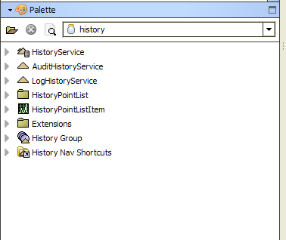
In general, a NumericInterval should be selected for numeric data such as a space temp. In contrast, a BooleanCOV (change of value) should be used for on/off type data such as a fan status. Using a NmericCOV on something like a space temperature would result in the trend log filling vary quickly as each change of the temperature would be logged. Similarly, it is best to avoid using a BooleanInterval as it would miss the exact moment a change occurs. Drag the appropriate trend from the palette onto the points to be monitored.

Example 2 – Trend Configuration
After adding a trend to the station, the next step is to configure the history point. Double click on the newly added history extension. The screen below will appear.
Numeric Interval History Configuration
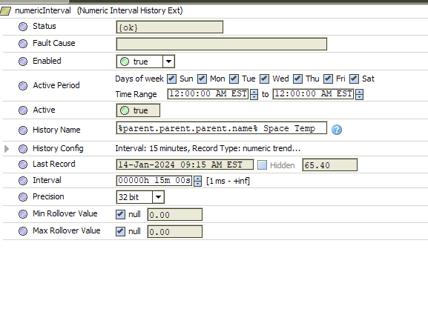
The firs step in the configuration process is to set the history name. Use of the b formatting “%parent.parent.parent.name%” will grab the device name and the specific data can then be appended such as “Space Temp” or “Airflow”.
Do not use “%parent.parent.parent.name% %parent.name%”. Other contractors will use this to perform a mass insertion of histories on all of points without any configuration. This is not acceptable practice. Doing so will grab the point name which is often difficult to decipher by the end user due to lack of spaces and abbreviations. Example:“VAV21 ActFlowSP” is not an acceptable history name.
Do not use underscores in history names. Spaces are acceptable and underscores make the system look archaic and difficult to read.
Comparison of proper and improper name formatting
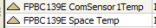
By default, a history stores 500 records or about 5 days on interval types with the default 15-minute interval. The record limit can be increased by expanding the “History Config” section of the extension. In this area, the “Capacity” cane increased. If 90 days of trends are needed, for example, this would be a capacity of 8640 records.

The interval can be adjusted higher or lower on an interval type history to control how often a record is taken.
After a history extension is configured as needed, be sure to enable so that data begins to be recorded. The extensional now be coped and pasted to additional points if desired.
Use of Program Service
Following the steps outlined in the first training, trends can be added or edited to a station en masse.

Deleting Trends
Example 1 – Deleting trends
There are times that old trend data needs to be removed, such as copying an existing station for use on a new site. To access the window to delete old trend data, right click on “History” in the nav tree, then highlight “Views”, then select “AX Database Maintenance”.
Accessing trend deletion screen
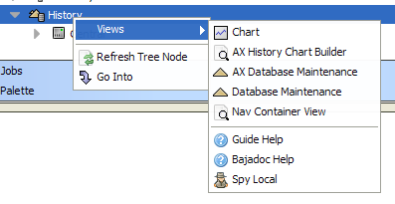
In the main window, select the trend data to be deleted. Click the arrow point to the right in the center of the screen. Select the “Delete Histories” button, then click “Run Maintenance”. Note that while this does delete all history, it does not delete the history extensions, so any active history extensions will repopulate with new data shortly.

Exporting Trend Data
Example 1 – Exporting to csv (excel)
Under certain circumstances there is a need to export trend data for validation purposes. To access trend data for export, under the “History” section in the nav tree find the trend that needs to be exported, then right click, highlight “Views”, then select “AX History Table”.

Accessing trend data
In the main window, the time range can be selected at the top left corner. If left at default, all data is displayed.
To export trend data, click on the blue button in the top right section of the title bar for the history records then select “Export”.
Exporting trend data
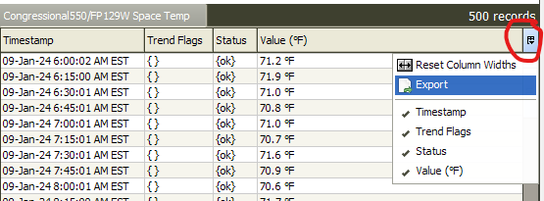

A popup will appear. Select “HistoryTable to CSV” from the dropdown. Next, click browse and choose the location to which you would like to save the file. Finally click “OK” button to complete the export.
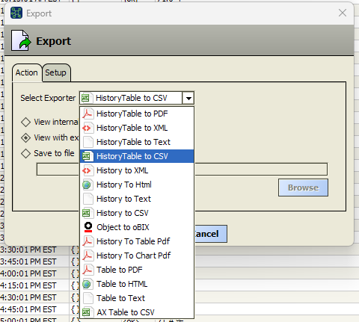

Accessing Alarm Palette
Alarms are used to alert users to fault conditions or possible system issues. One distinct aspect of Niagara alarms is they cannot be mass added via program service. Attempting to do so may appear to work, but it will not function correctly. Alarms can be added in batches with the use of Vykon Pro module which will be covered under future training documents.
Unless given direction otherwise by a specification that is to be validated by a commissioning agent, alarms should be used sparingly, limited only to notifications of major equipment issues such as a low limit trip of fan failure. Use of alarms to monitor room temperatures is not advisable as there is a strong likelihood of nuisance trips.
Example 1 – Alarm Extension from the Alarm Palette
In Niagara 4, if the palette window on the left-hand side is not already open, from the menu bar at the top select “Window”, then “Sidebar”, then select “Palette”. Next, click the open folder icon in the palette window. A popup will appear. Type “alarm” in the filter field. The alarm module is now listed and highlighted. Click “OK” button. The alarm palette is now visible. Expand extensions view the list of alarm types that can be used.
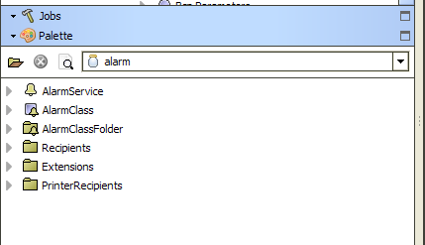

In general, a BooleanChangeOfStateAlarmExt should be selected for equipment failure like a supply fan or an alarm conation like a low limit trip. numeric data such as a space temp. An OutOfRangeAlarmExt would be used for monitoring numeric data, like a supply temp on a 100% outdoor air unit. Some third-party devices use Enum points to report alarms, so an EnumChangeOfStateAlarmExt would be appropriate in that scenario. Drag the appropriate alarm extension from the palette onto the points to be monitored.
Creating Alarm Class and Console Recipient
Inside the alarm palette, there are two key components for implementing alarms in the station. First is the alarm class. An alarm class is a group of alarms that are routed together to the same end point, called a recipient, which is the second component needed. A recepient could be an alarm console, a supervisor, or an email. .
Example 1 – Adding a Console Recipient and Alarm Class
In the nav tree, expand the services container. The “AlarmService” should now be visible. Double click the Alarm service to view the associated wire sheet. On a fresh station, only a default alarm class would be present. Drag a ConsoleRecipient from the alarm palette to the wire sheet. In most systems, only one console is used, so the default name is fine. While outside the scope of this particular training, the newly added console can be embedded in a px page to cleanly display alarms to the user. Copying an existing px is the usual approach, but it is important to ensure the alarm console view embedded in the px has the ord pointed at the correct console added under the AlarmService.
The next step is to drag in an AlarmClass from the alarm palette. Multiple classes can be used if there is a need to differentiate between critical alarms and minor maintenance tasks like dirty filter. However, real world usage suggests that for the vast majority of users, a single alarm class with only critical alarms linked is appropriate. The newly added alarm class can be renamed if needed. The “Alarm” slot of the newly added alarm class should be linked to the “Route Alarm” slot on the Console Receipient.
A station will come with a default class that cannot be deleted. The default class should not be linked to consoles or emails under most circumstances. This is because a controller going offline from something as simple as routine service shutting off power to a unit will trigger a ping failure alarm which will be nuisance alarm.
Linked alarm class and console recipeint
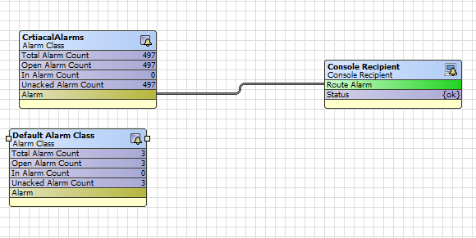

Configuring Alarm Extensions
Example 1– Alarm Configuration
After adding an alarm extension to a point, the next step is to configure the alarm. Double click on the newly added alarm extension. The relevant configuration fields are described below.
- Alarm Inhibit – Prevents a point from going into alarm that otherwise would when set to true. Not commonly used, but when it is placed into service, it would be linked to a something like a time delay on a fan status such that the alarm for the supply temp on a 100% outdoor unit does not trigger until the unit is running.
- Time delay/Time Delay to Normal – Prevents a point from going into or out of alarm for a specified period of time. This can be used to give a piece of equipment time to warmup or detect status before an alarm is triggered.
- Alarm Enable – It is advisable to uncheck the “toFault” option which would prevent an alarm from being generated from a point going into fault due to power or comm issues/
- Source Name – This is the name of the alarm the user will see. Uses the same b formatting as trends. Use of “%parent.parent.parent.name%” plus the specific failure type is advisable. Example “%parent.parent.parent.name%” Fan Failure”
- To Offnormal Text/ To Normal Text – Additional data can (but is not required) be added about the alarm that will be sent to the user when the point goes into or out of alarm.
- Offnormal Algorithm (BooleanChangeOfState) – Select whether a true or false value represents an alarm condition.
- Offnormal Algorithm (OutOfRange) – Values for high, low, and deadband are configured. The checkbox will need to be checked for low limit and/or high limit depending on desired use. Additionally, High and Low Limit text fields allow the use of specific information to be sent to the user depending on the condition of the alarm. For example, the text “High Supply Temp” might be sent on a high temp condition and “Low Supply Temp” might be sent on a low temp condition.

Offnormal Algorithm Example
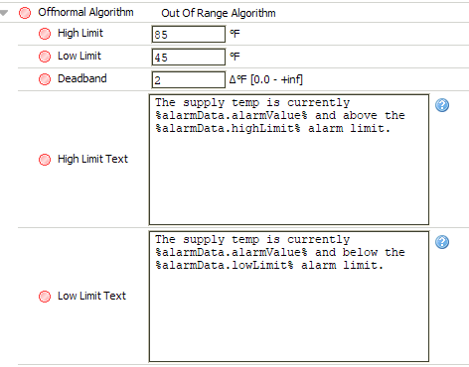

Note the use of the b formatting %alarmData.alarmValue% to send the current value of a point in alarm.
- Select the appropriate alarm class for the alarm to be routed to.

