Custom Controls Internal Training #2
Schedules
Overview
Properly implementing and managing schedules in Niagara helps our customers save money and allows us to add additional value above and beyond. Implementing schedules poorly is easy. Correctly implementing schedules with redundancy takes a bit more care, but it is not difficult and will separate us from the competition.
Creating Schedules
While it will not be required to create a schedule from scratch for every project (copy and paste is your friend), it is important to know the process of creating a schedule for those occasions where there is not ready access to a station with appropriate scheduling to copy from.
Example 1 – Schedule from the Schedule Palette
In Niagara 4, if the palette window on the left-hand side is not already open, from the menu bar at the top select “Window”, then “Sidebar”, then select “Palette”. Next, click the open folder icon in the palette window. A popup will appear. Type “schedule” in the filter field. The schedule module is now listed and highlighted. Click “OK” button. The schedule palette is now visible.
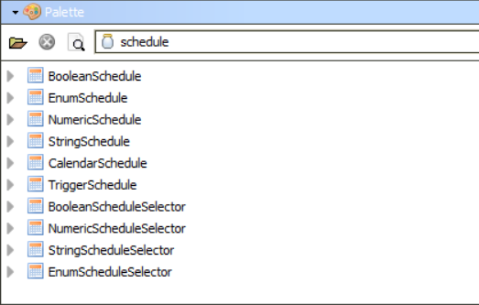
In general, an Enumerated Schedule should be selected for most use cases. It offers the flexibility to function as a numeric or Boolean schedule without any of the restrictions. Drag a schedule from the schedule palette to an appropriate location in the station such as the BcpBACnetNetwork. If many schedules are to be used, it is recommended to create a folder to hold all the schedules.

Example 2 – Schedule graphic
After adding a schedule to the station, the next step is to apply a px file to the schedule to make it easy to use and give a clean, consistent look to the control system. While it is possible to link directly to a schedule without a px view, it breaks the ease of navigation and will generally give the system a cheap and incomplete feel.
Schedule with proper px overlayed
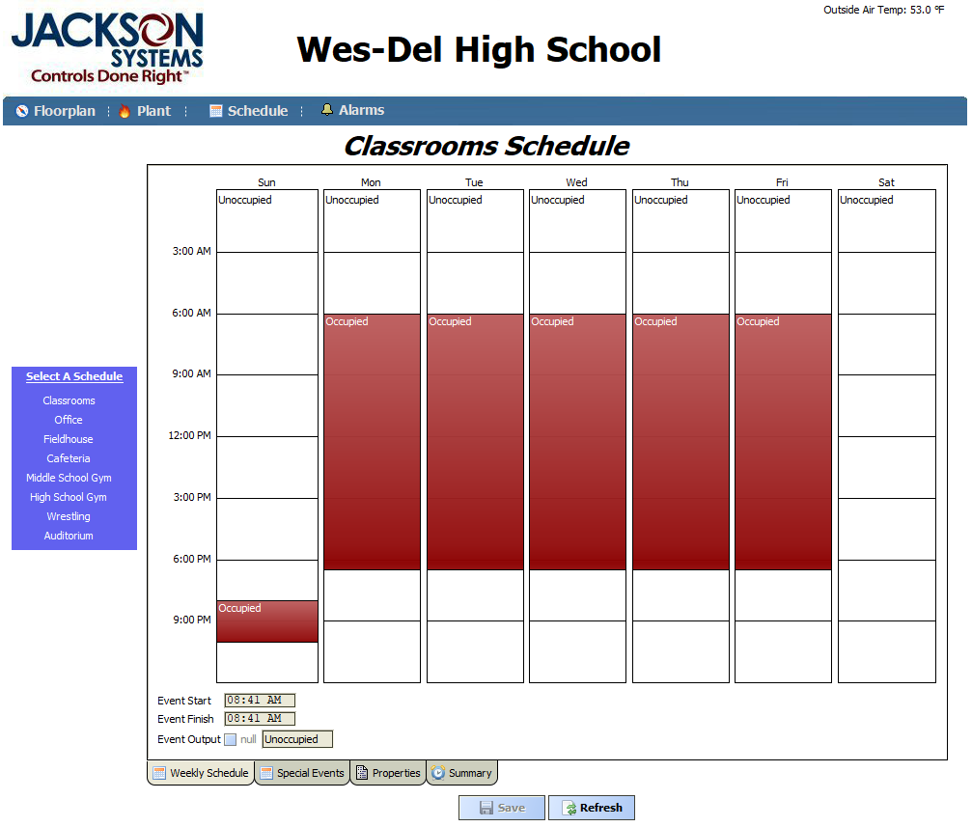
Schedule without px overlay. Note the lack of menu bar.
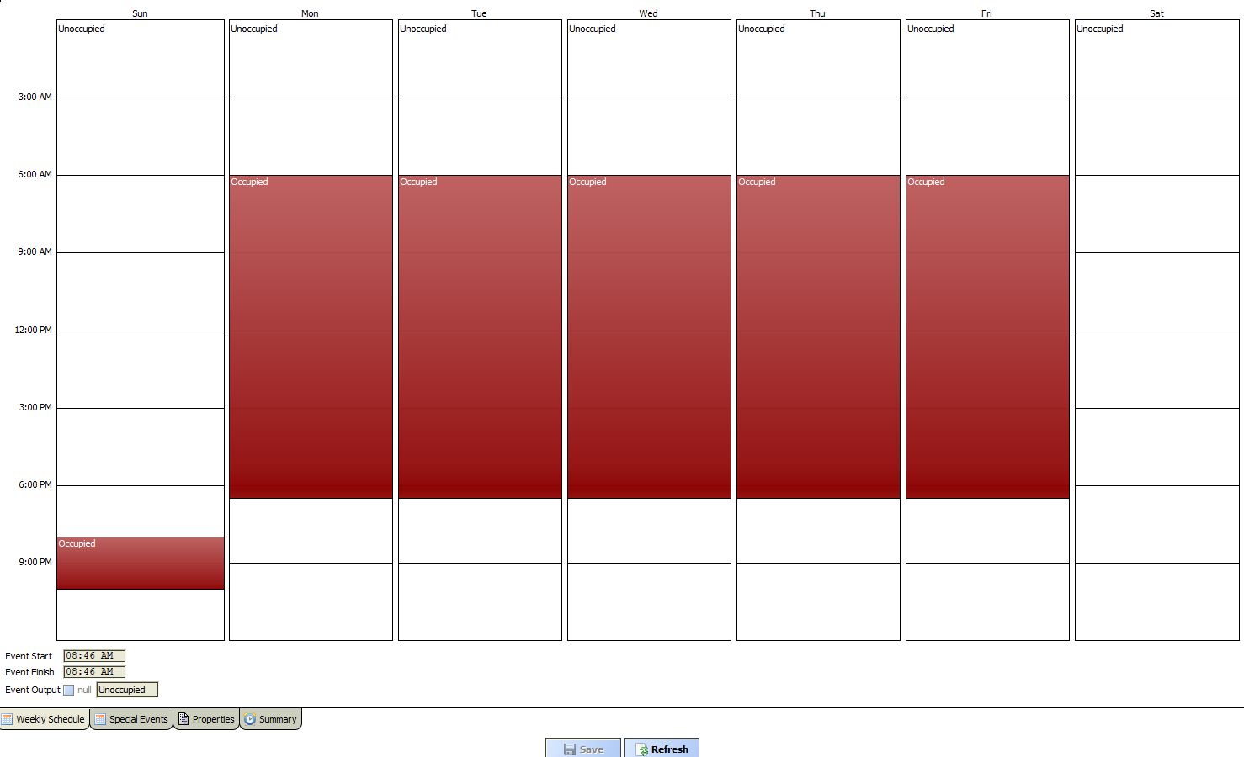
Creation of the px for schedule is outside the scope of this document; however, an appropriate px can be copied from a completed project station if one is not already present. Note the ‘select a schedule’ section in blue on the left-hand side of the px. Add or remove entries to match the number of schedules present on the station currently being built. Each entry should have the name updated and a hyperlink updated to point to a schedule in the station.
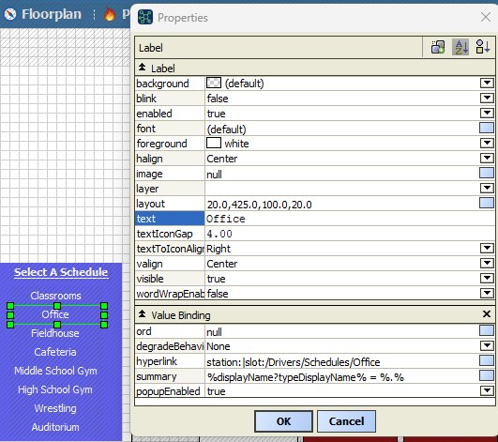
Final Note On Schedule Graphics
The schedule interface is slightly different when viewed from the web browser. When doing a project training/handover to a customer, it is best to be refamiliarize with the web view shortly before the training begins.

Configuring Schedules
For the purposes of this training, it is assumed that you know how to manipulate the weekly schedule.
Example 1 – Configuring Enumerations
Lonworks and BACnet both implement standard enumerated values for schedules. It is important to commit these to memory.
BACnet: 1 = Occupied, 2 = Unoccupied
Lonworks: 0 = Occupied, 1 = Unoccupied
A schedule that already has been copied from another station is likely to already have these values configured, but it is important to remember to validate the values to ensure they match the type of system being implemented. To validate or update the schedule enumeration, click the “Properties” tab at the bottom of the schedule view. Click the double arrows next to the existing range in the “Facets” field. A popup will appear. Click the box in the value field of the popup. A smaller popup will appear with another set of double arrows. Click this button, and a final popup will appear allowing the addition, modification, or deletion of the enumerated values for the schedule. After making any necessary changes, click the “OK” buttons until the base screen is displayed. Finally, if the schedule enumeration is modified, ensure the “Default Output” is set to “Unoccupied” on the “Properties” tab and return to the “Weekly Schedule” tab to update the weekly schedule to reflect the newly modified enumeration. Failing to do so will likely result in unexpected behavior.
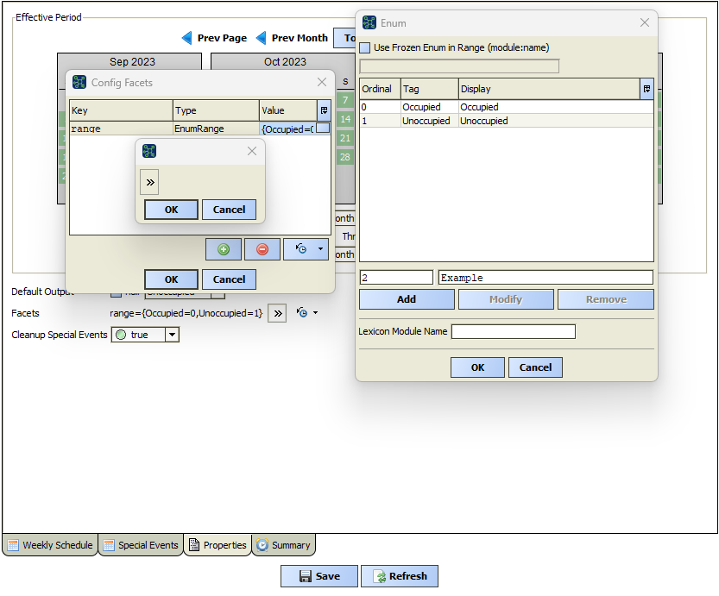
Some manufacturers or other contractors deviate from these Lon and BACnet. It is important that all Jackson Systems projects do not deviate from the standard so that when the system is serviced by someone other than the original project manager, the chance for confusion or mistake is minimized. Strategies to deal with devices not following the standard or system with mixed use of Lon and BACnet will be presented in the next section.

Example 2 – Special Events
Special events fall into two different categories: occupied and unoccupied special events. Unoccupied events are typically going to be holidays. Occupied events are going to be cases when a space is occupied outside the normal weekly schedule. This is particularly useful for spaces like gymnasiums that often have events schedule out months in advance. With a bit of training, the end user can spend a short amount of time to schedule all their events for several months in advance.

To add a special event, click the “Special Events” tab at the bottom of the schedule page. Next, click the green “Add” button. A popup allowing for the configuration of an event will be presented. For most events, the default type of “Date” is acceptable. In the screenshot below, the configuration for a Christmas event is displayed. Note that if the year is selected as “Any Year”, the event will reoccur every year without having to renter it.

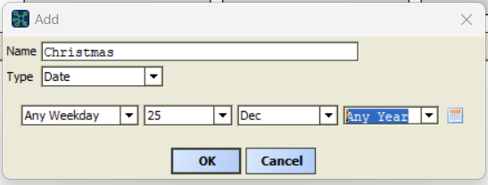
In the screenshot below, a configuration for an event type ‘week and day’ is seen for Labor Day.
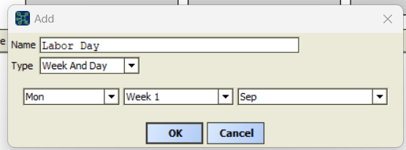

After adding the event, the final step is to select the type of event (occupied or unoccupied) and the times the event is to occur. Simply click and drag in the time section on the right-hand side of the “Special Events” tab. Tweak the time as needed and select “Occupied” or “Unoccupied” as appropriate from the drop down. Most holidays can be scheduled unoccupied all day, but some facilities may choose to implement an early unoccupied period on a day like New Years Eve.

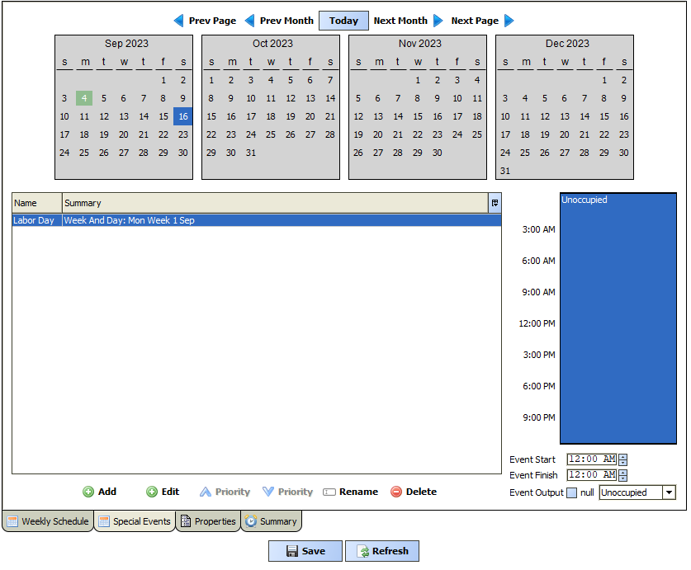
To be clear, only the hours scheduled on the special events tab will override the weekly schedule. Any hours left unscheduled will follow the standard weekly schedule.
Calander Schedules
A Calander Schedule is a special type of schedule under which Holidays can be added and used across many individual weekly schedules. This prevents the need to add and manage holidays for more than one schedule. The presence of a Calander Schedule increases the likelihood that facility personnel will use scheduling to the full potential.

Example 1 – Using a Calander Schedule
From the Schedule palette, select a CalendarSchedule object and drop it in the same components space as your standard schedules. A slightly modified px file is required for displaying the Calendar Schedule. To generate such a px, navigate to the file directory and duplicate your existing schedule. Assign the newly created px as a view to the CalendarSchedule object (same procedure as previously performed in the Schedule Graphic section of this document). Double click on the CalendarSchedule object to view the object with the newly created px file assigned. Enter the px edit mode from the menu bar at the top and then delete the existing schedule view. This is required as a CalendarSchedule requires its own view type to embed in the px. Drag the CalendarSchedule object onto the px and resize the embedded view to the appropriate size on the page. The page header should also be updated to reflect the use of the page. “Holiday Schedule” often makes a good title.
The Calander Schedule is now complete. The process for adding events is identical to the special events tab on an EnumSchedule. Once all the events have been added, navigate to a schedule that the CalanderSchedule is to be assigned to. Click the “Special Events” tab at the bottom and then click the green add button. On the popup, select the type as reference. The calendarSchedule should populate. After selecting “OK”, the Occupied or Unoccupied hours can be assigned.
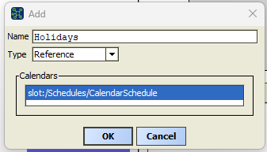

Mixed Environments and Enumeration Standard Deviation
Per the previous section, we know that Lon and BACnet have different enumeration standards for implementing schedule. In fact, it is illegal for a BACnet multistate value to have a value of 0, so linking a lonworks enumerated schedule to a BACnet MSV will result in a fault condition on that proxy point and the associated equipment may not start.
Example 1 – Using Select Blocks for Equipment Deviating From Lon or BACnet standard
Some devices such as factory RTU controllers or a device programmed by another contractor may not follow the enumeration standards. Using a select block, we can convert the standard enumerated value to the nonstandard value. To begin, navigate to the kitControl palette using the same steps previously discussed for the Schedule Palette. Next, scroll down until the “Selects” folder is visible. Choose and drag the select block that represent the type of occupied proxy that will be linked. The select block should be placed into the same component space as the schedule. For example, some RTU controllers will utilize a Boolean point for an On/Off occupancy point so in that instance a BooleanSelect would be appropriate.

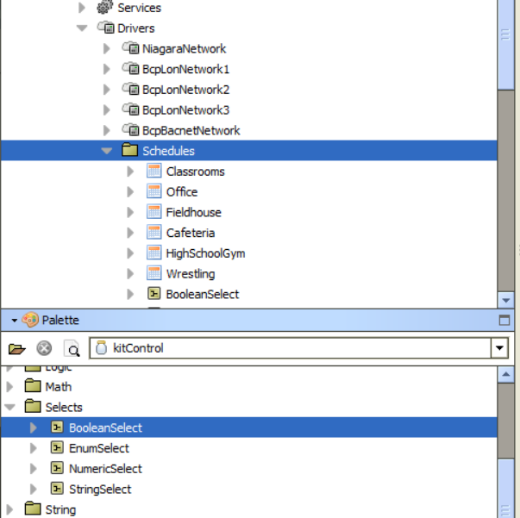
Next, link mark the schedule by right clicking on the schedule in the navigation tree and selecting “Link Mark”. Then right click on the select block just added and select “Link From X” where X is the name of the schedule link marked. A popup will appear. Choose the “Out” slot from the schedule on the left and choose the “Select” slot on the right. Click “OK”
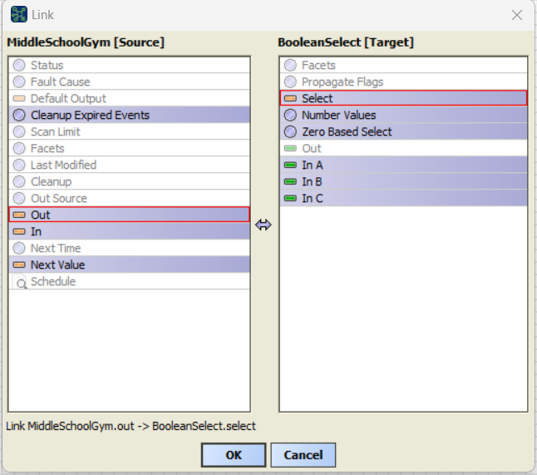
Double click on the select block to configure the nonstandard values implemented by third party devices. If the original schedule utilizes an enumeration value with a 0 (typically a lon schedule), set the “Zero Based Select” field to true. In this example, we want to convert 0=Occupied and 1=Unoccupied of the schedule such that select block outputs a true value when the schedule is occupied and a false value when the schedule is unoccupied. The screenshot below shows the appropriate configuration for this task. Study it to ensure understanding of the process.
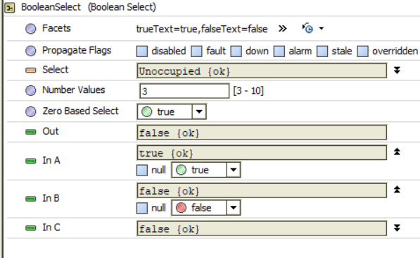
The select block is now configured for the enumeration and can be linked to the nonstandard occupancy point in the third-party device.
Example 2 – Converting Between Lon and BACnet Schedules
The process for using a single schedule for both BACnet and lonworks devices is similar to example 1 above, but instead of using a BooleanSelect, an EnumSelect would be used. The screenshot below shows appropriate configurations.
EnumSelect Configured For Lon to BACnet Conversion
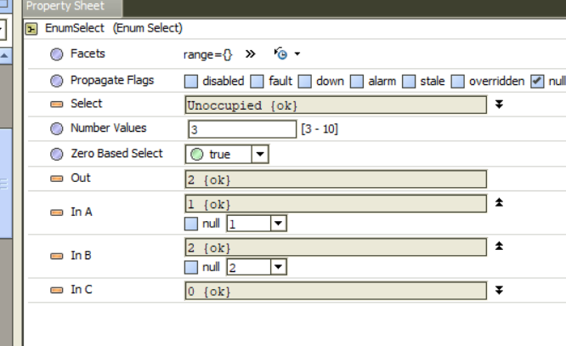
EnumSelect Configured For BACnet to Lon Conversion
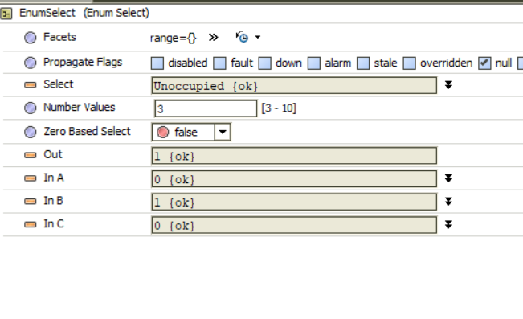

Linking Schedules
Example 1 – Manually linking schedules with link mark
Once a schedule is finalized, it needs to be linked to an occupancy point. This is accomplished by right clicking on the schedule in the nav tree (or select block in a conversion) and selecting “Link Mark”. The next step is to right click on the occupancy point and select “Link From X” where X is the name of the schedule link marked. Multiple occupancy points can be selected by holding the control key and clicking on each. Select the “Out” slot on the left hand pane (schedule side) and choose an appropriate slot for the occupancy point(s) on the right hand side. In general, BACnet points should be linked to “in13” as this places the schedule command higher than any stray write commands that might occur in the GFX code. In1 and in8 cannot be linked as these priorities are reserved for override functionalities.
If an object is already writing to a priority level, that slot will be grayed out.
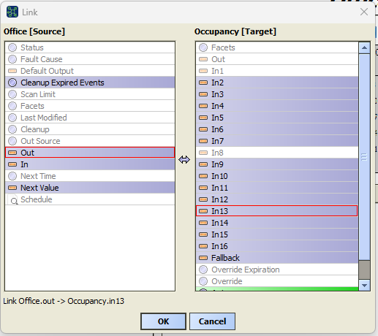

Example 2 – Linking schedules with program service
Reference page five of the program service training for detailed example of linking a schedule.

Example 3 – Reviewing and deleting schedule links
To review the source of an occupancy points link, right click on the point in the nav tree and select “views” then select “Relation Sheet”. The relation sheet view for that point will appear and show any schedule links that are present. Double click on a link to view the properties.
“Source Ord” field - will show the source from which the link is occurring (typically a schedule or a select block for an occupancy point).
“Source Slot Name” - represents what slot the value is coming from on the source ord.
“Target Slot Name” – slot to which the value is being written on the point being examined.
These values are all editable. Clicking the folder icon next to the source ord allows easy access to select a different source ord. This can be useful if the wrong schedule was applied to a handful of units, and they need to be redirected to a different schedule.
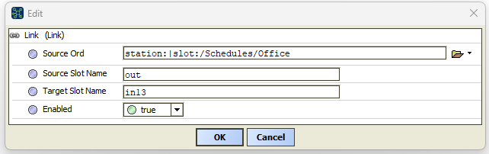
The inverse is also applicable. The “Relation Sheet” view for a schedule component will show all of the points to which the schedule is linked. These links can be deleted to remove points from a particular schedule.
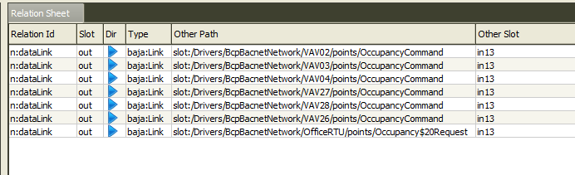
Setting Tuning Policy for Schedules
Tuning policies determine how often points in Niagara are read or written to. The default policies only write when a point is updated. For a value like outdoor air temperature, this is usually not an issue as the temperature changes frequently and being off by a tenth of a degree has no ill effects if a message update fails to be written as another change will be coming in shortly. In contrast, an occupancy value typically only changes twice a day. As such a missed message will result in wasted energy or a piece of equipment failing to start.
Example 1 – Creating and applying a new tuning policy
For the purposes of this document, we will only cover BACnet tuning policies. Lonworks policies are more difficult to master so are outside the scope of this training. In the nav tree, expand the BcpBacnetNetwork. Next, expand the “Tuning Policy” slot. Right click on “Default Policy” and select “duplicate”. The name of the new policy should be something like “occupancyPolicy”.
Double click on the newly created policy to view the policy configuration in the main window. Set the “Max Write Time” to 10 minutes. This will cause the JACE to resend the occupancy command every 10 minutes, regardless of if the value changes.
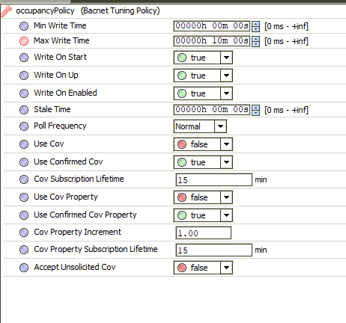
The next step is to apply this policy to all of the occupancy points. Go to “ProgramService” and use the “Find Objects” function to find all objects with parent.name = OccupancyCommand (or whatever the name of the occupancy point is for your controller). Use additional restrictive criteria as needed to filter the search.

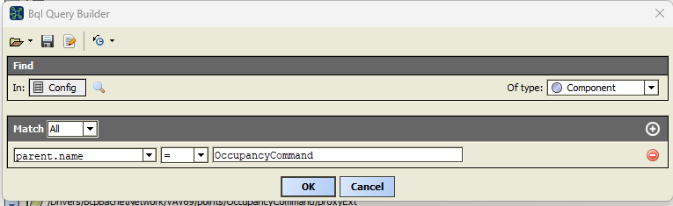
The results should display all the proxyExt objects for the OccupancyCommand points under each controller. Click the “Edit Slot button”. In the popup, select “tuningPolicyName” from the project dropdown. In the “New Value” field, type the name of the newly created tuning policy and select “OK”. Your occupancy points are now using the new tuning policy.

Schedule Overrides
Schedules typically write their values to other points in the station; however, under certain circumstances a schedule (or all schedules) may need to be forced occupied by being written to themselves.
Example 1 – Writing to schedule input
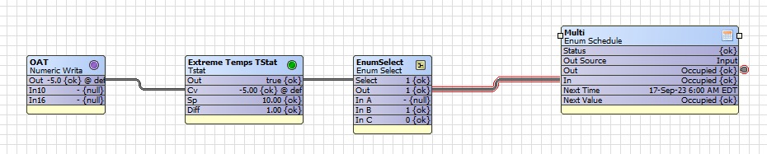
A common use case is an extreme cold event. Basic logic can be implemented in the JACE to prevent the system from going unoccupied when the outside air temperature is below a certain threshold. This logic would trigger a Boolean value to change to true. Using an EnumSlect block, the true condition can be configured to push the occupied value while a false condition will yield a null value. The out slot of the “EnumSelect” should be linked to the “in” slot of the schedule.

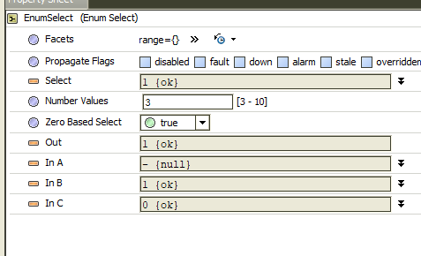
When the cold weather event is not active, a null value is written to the “in” slot of the schedule and the schedule functions like normal. Whenever the cold weather event is activated, a value is written to the “in” slot. When this occurs all other scheduling considerations are bypassed and the schedule will become occupied.

